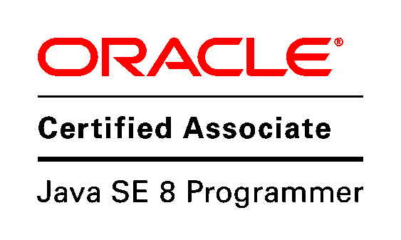

**Chee Yi Yong**

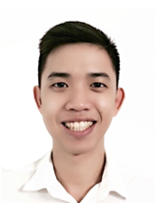

**Profile Summary:**

Yi Yong is an NTU graduate pursuing his career in IT development. Currently working in Capgemini Singapore Pte Ltd. where he is exposed to in-depth Java development to be in the financial sector. He is an Oracle Certified Associate who is adept in using Java 8.

**Education background:**

|  |  |
| --- | --- |
| **Nanyang Business School, Nanyang Technological University** | Aug 2013 – May 2017 |

*Double Degree Programme in Business (IT)**& Computer Science (Specialization in Digital Media)*

* Graduated with 1st Class Honours in Computer Science & 2nd Upper Division Honours in Business (IT)

**Technology Skill Set:**

* **Programming Languages:** C++, Core Java, JDBC, Multi-threading, Collections
* **Tools:** Qt, OpenGL, Spring Tool Suite, Eclipse, SonarQube, WebStorm, Bootstrap, Maven
* **Databases:** MySQL, Oracle Database 11g
* **Web:** Servlets, JSP, Spring
* **ORM:** JPA, Hibernate
* **Front End:** Ember.js, HTML/HTML5, CSS3, JavaScript
* **SCM:** Git

**Professional Experience:**

|  |  |
| --- | --- |
| **Capgemini Singapore Pte Ltd** | July 2017 – Current |

*Associate Consultant (Java Developer)*

* Undergone a 9-week long training program with exposure to Java, SQL, JavaScript, SPRING framework, etc. before being deployed to the Client for development work.

**Internships:**

|  |  |
| --- | --- |
| **CACANi Pte Ltd** | May 2016 – Jul 2016 |

*Junior Software Developer*

* Studied Open Source programs and to written certain documentation explaining some functionality which could be useful for future development. Exposed to C++, Qt and OpenGL during internship period.

**Trainings:**

Capgemini 9-weeks intensive Java, Spring, SQL training

* Core Java: Java, Collections Framework, Exception Handling, Multi-Threading
* SQL:MySQL, Oracle Database 11g Express Edition

**Certifications**

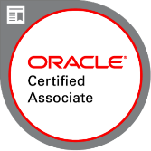

Oracle Certified Associate Java SE 8 Programmer

**Academic Achievements:**

|  |  |
| --- | --- |
| **Hall Olympiad Closing Ceremony** | Aug 2016 – May 2017 |

*Hall 5 Dance Captain*

|  |  |
| --- | --- |
| **Hall 5 Dinner & Dance Committee** | Aug 2013 – Aug 2015 |

*Creative Director and Events Coordinator*

|  |  |
| --- | --- |
| **NTU CAC Breakdance Club** | May 2014 – May 2015 |

*Vice Chairperson*